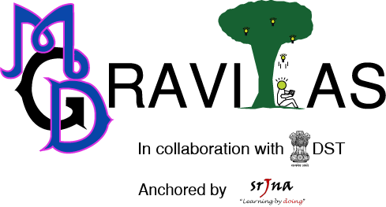
Proforma Of Participation

Day – 1

Name Of School:-
Address:-

Contact Number:-
E-Mail Id:-
Name Of The Escort Teachers:- 1.
2.

S. No. | Event Name | Participant’s Name | Standard
1. | FARRAGO-3 D Collage making | 1.
1. | FARRAGO-3 D Collage making | 2.
2. | MODDLE - Graffiti | 1.
2. | MODDLE - Graffiti | 2.
3. | NOESIS - Quiz | 1.
 |  | 2.
 |  | 3.
4. | INNOVITA – Modal Making | 1.
4. | INNOVITA – Modal Making | 2.
4. | INNOVITA – Modal Making | 3.

Date:-
Signature of Principal
Proforma Of Participation
GRAVITAS -FEST
Day – 2

Name Of School:-
Address:-

Contact Number:-
E-Mail Id:-
Name Of The Escort Teachers:- 1.
2.

S. No. | Event Name | Participant’s Name | Standard
1. | FRESCO – E-painting | 1.
1. | FRESCO – E-painting | 2.
2. | GENETIC MAKE OVER  Face Painting | 1.
2. | GENETIC MAKE OVER  Face Painting | 2.
3. | SPOOF SOOP – Music Parody | 1.
3. | SPOOF SOOP – Music Parody | 2.
3. | SPOOF SOOP – Music Parody | 3.
4. | ENACT - Elocution | 1.

Date:-
Signature of Principal
Note: The above Performa has to be sent back before 1st December either by an e-mail or by post to nearest Nodal Partner School.
Email id: apply@srjna.com
For further queries contact: +91 9587884151/55 (Om Prakash)


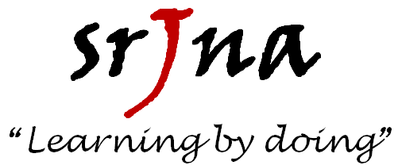


Co-organized by;

